**DIABETIC RETINOPATHY DETECTION**

Enrol. No. : 13103588

Name of Student : Jayant Yadav

Name of supervisor: Dr. Vikas Saxena



**May - 2017**

Submitted in partial fulfillment of the Degree of

**Bachelor of Technology**

in

Computer Science Engineering

**DEPARTMENT OF COMPUTER SCIENCE ENGINEERING & INFORMATION TECHNOLOGY**

**JAYPEE INSTITUTE OF INFORMATION TECHNOLOGY, NOIDA**

**(I)**

**TABLE OF CONTENTS**

**Chapter No. Topics Page No.**

Student Declaration II

Certificate from the Supervisor III

Acknowledgement IV

Summary V

List of Figures VI

List of Tables VII

List of Symbols and Acronyms VIII

**Chapter-1** **Introduction** 10 to 16

1.1 General Introduction

1.2 List some relevant current/open problems.

1.3 Problem Statement

1.4 Empirical Study

1.5 Overview of proposed solution approach and Novelty/benefits

**Chapter-2** **Background Study** 17 to 22

2.1 Literature Survey

2.2 Integrated Summary

**Chapter 3: Analysis, Design and Modeling**  23 to 30

3.1 Functional and Non Functional requirements

3.2 Overall architecture with component description and dependency details

3.3 Design Documentation

3.3.1 Data Structures and Algorithms / Protocols

3.4 Risk Analysis and Mitigation Plan

**Chapter-4 Implementation and Testing** 31 to 38

4.1 Implementation details and issues

**Chapter-5 Testing** 39 to 40

5.1 Testing Plan

5.2 Limitations of the solution

**Chapter-6 Findings & Conclusion** 41 to 42

5.1 Findings

5.2 Conclusion

5.3 Future Work

References 43

Appendices 44

**(II)**

**DECLARATION**

I hereby declare that this submission is my own work and that, to the best of my knowledge and belief, it contains no material previously published or written by another person nor material which has been accepted for the award of any other degree or diploma of the university or other institute of higher learning, except where due acknowledgment has been made in the text.

Place: Signature:

Date: Name: Jayant Yadav

Enrollment No: 13103588

**(III)**

**CERTIFICATE**

This is to certify that the work titled “**Diabetic Retinopathy Detection**” submitted by **Jayant Yadav (13103588)** in partial fulfillment for the award of degree of **Bachelor of Technology** of Jaypee Institute of Information Technology University, Noida has been carried out under my supervision. This work has not been submitted partially or wholly to any other University or Institute for the award of this or any other degree or diploma.

Signature of Supervisor :

Name of Supervisor: Dr. Vikas Saxena

Designation: Associate Professor (Computer Science & IT Department)

Date:

**(IV)**

**ACKNOWLEDGEMENT**

The members of the Group gratefully thank all the members of staff **JAYPEE INSTITUTE OF INFORMATION TECHNOLOGY, NOIDA** for their kind hearted cooperation and guidance, which helped us to our project development.

We acknowledge the support of **Dr. Dharmveer Singh Rajpoot (Phase-1,2,3 evaluator), Mrs. Shardha Porwal (phase-1 evaluator), Mr. Mahendra Gurve (phase-2 evaluator) and Ms. Mukta Goyal (pahse-3 evaluator)** for pointing out the flaws and providing their valuable advice for our progress.

Last but not least we would like to pay our regards to **Dr. Vikas Saxena**, project coordinator

who provided us with some useful guidelines for making the project report and also his kind

cooperation at every step of the project.

Signature:

Name of Student: Jayant Yadav

Enrollment Number: 13103588

**Date:**

**(V)**

**SUMMARY**

Diabetic Retinopathy is the world’s leading cause of blindness. On an average, it affects 93 million people. The longer a person has diabetes, the higher his or her chances of developing diabetic retinopathy. Right now, detection of DR is a time consuming and a manual process which requires a trained opthalmologist to examine and evaluate digital fundus photos of the retina. But by the time they submit their reviews, ie. A day or two later , these delayed results lead to lost follow ups, miscommunication and hence delayed treatment. So, there is a need for a screening using computer vision including image classification, pattern recognition and machine learning.

With some diligent work and honest approach, we hope to make this detection process in large a success. This project showcases how the use of computer vision and machine learning algorithms, can help medical science to deal with large number of patients suffering from diabetic retinopathy easily.

Signature of Student

Name

Date

**(VI)**

**LIST OF FIGURES**

**Page No**

Fig1a: Normal Vision 10

Fig1b: The same view with diabetic retinopathy. 10

Fig2:Fundus image showing Diabetic Retinopathy (Right eye) 11

Fig3: Fundus image showing no Diabetic Retinopathy (Left eye) 12

Fig4: Diagram of a human eye 12

Fig5: Eye Diagram suffering from Diabetic Retinopathy 13

Fig6: Exudates 14

Fig7: Dot Hemorrhages 14

Fig8: Morphological closing 26

Fig9: Histogram Equalization 26

Fig10: Erosion 27

Fig11: Dilation 27

Fig12: Optic Disk Detection 32

Fig13: Gradient image 33

Fig14: Gradient Image after Thresholding 33

Fig15: Exudates detection 35

Fig16: DH detection 36

Fig17a: Classification 36

Fig17b: Classification 37

Fig18: ANN Model 38

Fig 19: Classification using NN 41

Fig20: Project Plan 44

**(VII)**

**LIST OF TABLES**

**Page No**

Table 1: Field study 11

Table 2: Risk analysis and mitigation plan 28

Table 3: Risk Area Wise Total Weighting Factor 30

Table 5: Testing 39

Table 6: Findings 41

**(VIII)**

**LIST OF SYMBOLS & ACRONYMS**

DR: Diabetic Retinopathy

MT: Morphological Transformation

DH: Dot Hemorrhages

NPDR: non-proliferated diabetic retinopathy

ANN: Artificial Neural Network

**Chapter-1**

**INTRODUCTION**

**1.1 Genereal:**

Diabetic Retinopathy is the world’s leading cause of blindness. On an average, it affects 93 million people.

It is an ocular manifestation of diabetes, a systemic disease, which affects up to 80 percent of all patients who have had diabetes for 20 years or more. At least 90% of these new cases could be reduced if there were proper and vigilant treatment and monitoring of the eyes. The longer a person has diabetes, the higher his or her chances of developing diabetic retinopathy.

Vision of normal and defective person:

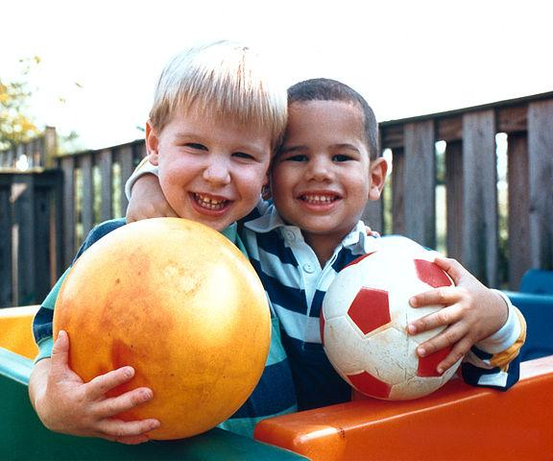 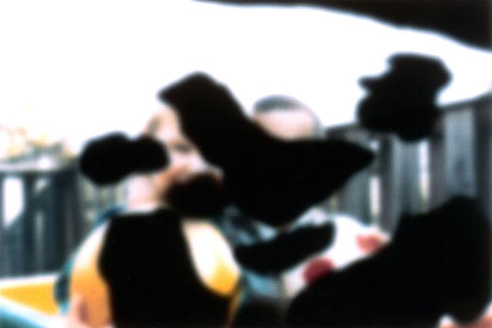

Normal Vision The same view with diabetic

retinopathy.

Fig1a Fig1b

**1.2 Relevant current/open problems:**

* Right now, detection of DR is a time consuming and a manual process which requires a trained opthalmologist to examine and evaluate digital fundus photos of the retina. But by the time they submit their reviews, ie. A day or two later , these delayed results lead to lost follow ups, miscommunication and hence delayed treatment. So, there is a need for a screening using computer vision including image classification, pattern recognition and machine learning.
* aExperts identify DR by alooking for the presence of lesions that must be associated with vascular abnormalities caused by the disease. This method is effective yet very resource demanding. Since the number of diabetic patients are growing, so is the number of patients suffering from DR, which would require more infrastructure to prevent blindness among them.

So, the there is a need for making automated method to detect DR through the means of scanning images. The following table has been taken as reference to show the number of people getting effected by this disease:

Table1:

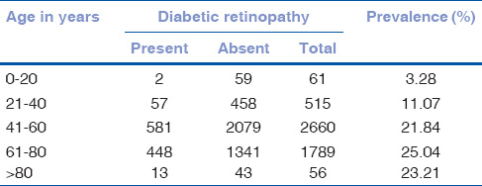

Age-wise distribution of diabetic patients and the percentage of those patients falling under DR in India.

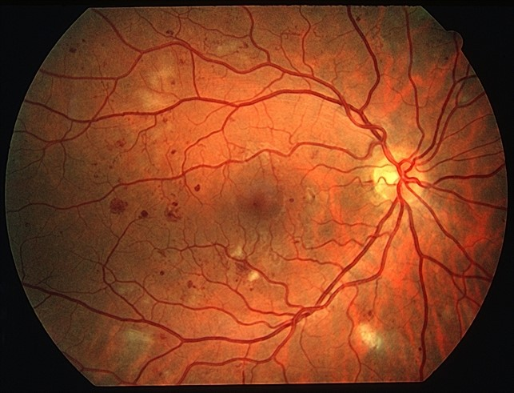

Fig2:Fundus image showing Diabetic Retinopathy (Right eye)

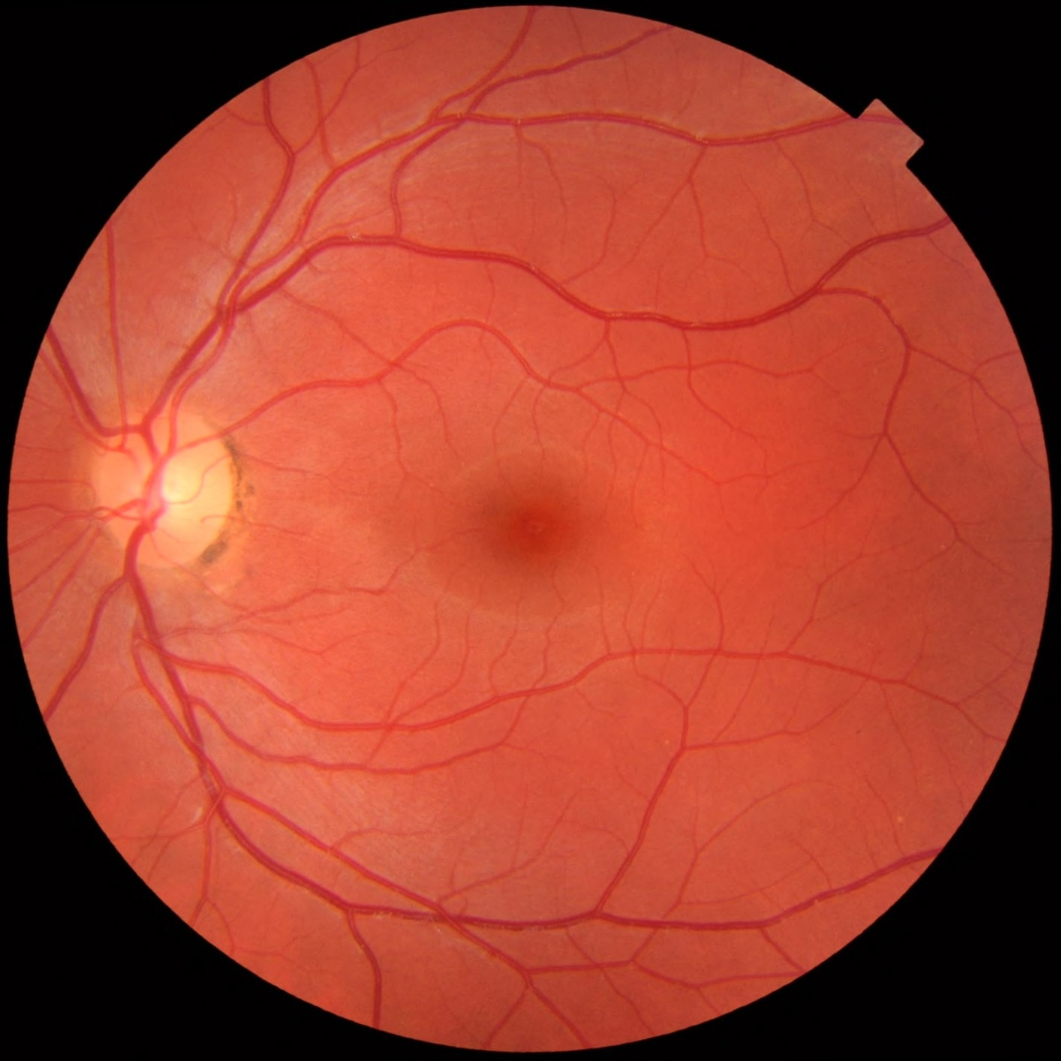

Fig3: Fundus image showing no Diabetic Retinopathy (Left eye)

**Signs and Symptoms of DR:**

* The first stage is called non-proliferated diabetic retinopathy or NPDR, in which there are no symptoms. The signs are not visible in the eye of the patients and they will have a 20/20 vision.
* The region Macular, in which blood vessels leak their contents, can happen in any stage of NPDR. This causes Macular edema. Its symptoms consists of blurred vision and darkened or distorted images of objects. About 10% of the diabetic patients can have thier vision loss due to this macular edema.

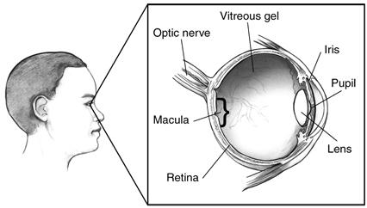

Fig4: Diagram of a human eye

* In the second stage, eye repairs itself to form abnormal new blood vessels at the back of the eye, which are very thin and fragile. So, these can burst and bleed (called vitreous hemorrhage) and blurs the vision even more. This forms a part of diabetic retinopathy.

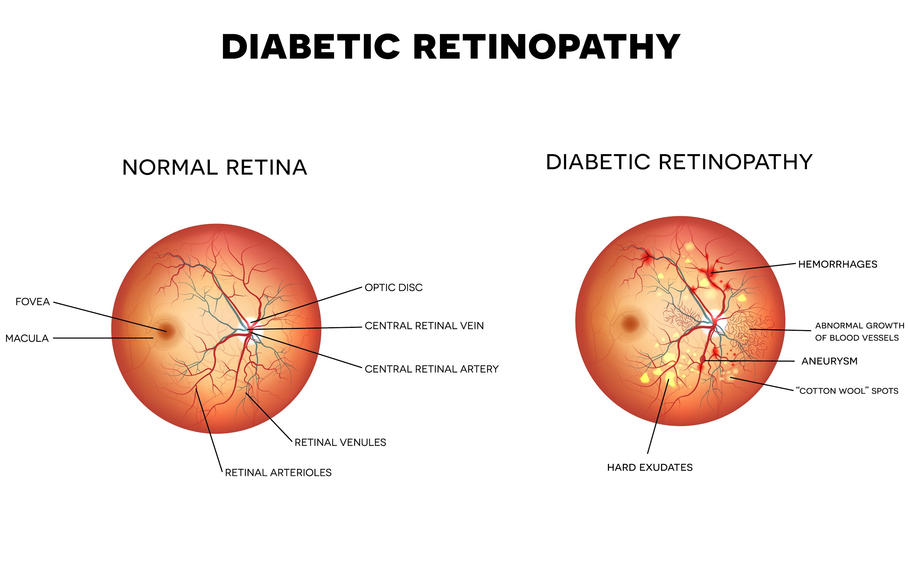

Fig5: Eye Diagram suffering from Diabetic Retinopathy

* The disease progresses that makes this severe nonproliferative diabetic retinopathy enter into an advance or proliferative (PDR) stage. In this stage too, the blood vessels proliferate and grow.

The DR detection includes detection of :

* Exudates

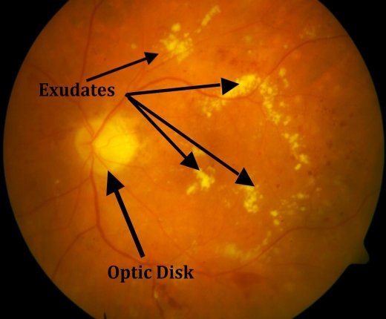

Fig6: Exudates

* And Dot Hemorrhages

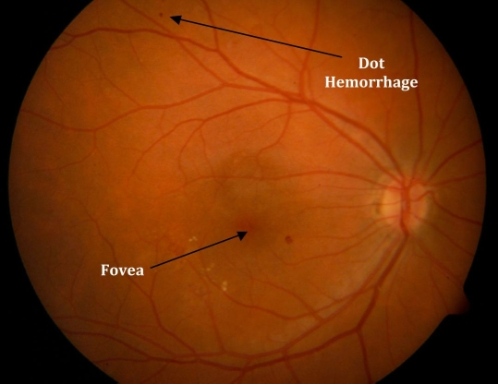

Fig7: Dot Hemorrhages

**1.3 Problem Statement:**

The patients with diabetes may be suffering from DR without realization. Since Proliferative diabetic retinopathy does not show any symptoms until they are in last stage of vision loss. With the help of image processing and machine learning, we can determine whether exudates and dot hemorrhages are developing or not , so that patients can take steps accordingly.

**1.4 Emperical Study:**

1. The current method for detection of DR involves pupil dilation of the patient first, so that the opthalmologist can clearly see the fundus of the eye. Then after few minutes of clinical examination of the eye, the doctor concludes whether the patient is suffering from vision loss due to diabetes.
2. Fluorescence Angiography technique is used, in which the patient is injected with fluorescence in the blood stream. This might also be given oraly. The retina is examained after few minutes under UltraViolet light, which enhances the thin and proliferating blood vessels, causing DR. This method might lead into having discolored saliva or dark colored urine, or sometimes orange.
3. Another way to detect the stage of Dr, in which the patient is in, opthalmologist uses Laser to get the diameter of the blood vessels in the fundus. This helps because this does not hae any bad effects on the sensitive blood vessels, which might else burst, making things worse.
4. They also use special Fundus Camera to get proper high definition images of eye of the patient, which is later examined by the doctor.

**1.5 Proposed Benefits:**

* This project takes an alternative, much better approach by focusing on analytics like, direct identification at the preprocessing stage.
* There are two different independent algorithms that we have developed to detect exudates and DH. The number of exudates and DHs are determind by the information like colour, gradients and morphology of the fundus photos.
* Finally, it uses the information such as indentifying physiologically observed states, directly, which some other algos ignore.

**Chapter-2**

**Literature Survey**

**2.1 Summary of papers:**

* Title : Diabetic Retinopathy Screening Using Computer Vision
* Authors:

1. Christopher E. Hann,University of Canterbury, Dept of Mechanical Engineering, Christchurch, New Zealand
2. J. Geoffrey Chase, Dept of Mechanical Engineering, Christchurch, New Zealand
3. James A. Revie, Dept of Mechanical Engineering, Christchurch, New Zealand
4. Darren Hewett, Dept of Mechanical Engineering, Christchurch, New Zealand
5. Geoffrey M. Shaw, Dept of Intensive Care, Christchurch Hospital, Christchurch, New Zealand

* Year of Publication: August 12 - 14, 2009
* Publishing Details:

Proceedings of the 7th IFAC Symposium on Modelling

and Control in Biomedical Systems, Aalborg, Denmark

* Summary:
  + The algorithms search for bad lesions in the fundus images which define the severity of DR.
  + The lesions are categorised into microaneurysms, haemorrhages and exudates based on their location, morphology and colour.
  + The paper presents two algorithms to detect DH and exudates in the digital eye fundus images. It exploits the image’s colour, morphology and intensity gradients in order to detect DH and exudates and thus conclude the presence of DR.

Title : Dynamic Thresholding Technique for Detection of Hemorrhages in Retinal Images

* Authors:

1. Akhilesh Sharma, Department of Electronics and Communication Engineering, Amity University, Noida, India
2. Malay Kishore Dutta, Department of Electronics and Communication Engineering, Amity University, Noida, India
3. Anushikha Singh, Department of Electronics and Communication Engineering, Amity University, Noida, India
4. M.Parthasarathi, Department of Electronics and Communication Engineering, Amity University, Noida, India
5. Carlos M. Travieso, Signal and Communications Department,

University of Las Palmas deGran Canaria,

Las Palmas de Gran Canaria, Spain

* Year of Publication: August 7 - 9, 2014
* Publishing Details:

2014 Seventh International Conference on

Contemporary Computing (IC3) , Noida, India

* Summary:
  + The paper proposes a dynamic thresholding based image processing technique for the detection of hemorrhages in retinal images.
  + The algorithm proposed in the paper uses the information of the colour and size of DH so as to classify hemorrhages from other dark lesions in the fundus images.
  + It also uses the knowledge of contrast amelioration, intensity changes and background estimation at the contours ie, gradient magnitude info with the help of morphological operations.
  + It uses thresholding and morphological trasformations to remove unwanted features from images, without affecting the accuracy and time required to execute.
  + The test result, when tested on large dataset, gave positive results of around 90% accuracy and therefore the said algorithm can be used in further development of automatic detection of DH and exudates in fundus images.
* Title : Automated detection of bright lesions from contrast

normalized fundus images

* Authors:

1. Ashish Issac, Department of Electronics and Communication Engineering, Amity University, Noida,India
2. Rishabh Madan, Department of Electronics and Communication Engineering, Amity University, Noida,India
3. Malay Kishore Dutta, Department of Electronics and Communication Engineering, Amity University, Noida,India

* Year of Publication: August 11 - 13, 2016
* Publishing Details:

2016 Ninth International Conference on

Contemporary Computing (IC3) , Noida, India

* Summary:
  + The proposed method works on selecting the best candidate pixels using following 3 methods:

1. Normalization using statistical features like mean and standard deviation.

2. Top-Hat transformation

3. Averaging Filter

* + The green channel is chosen as the prmary channel to work upon as it provides better contrast of the objects in question. This is channel is further divided into small blocks and their mean and standard deviation is carried out. This is used with the global mean and standard deviation in order to normalize the contrast of green channel.
  + Then this green channel extracted is subjected to topht transformation and average filter, with contrast enhanced image and then these 3 images are thresholded to obtain possible candidates for exudates. The false pixels are rejected by selecting only those pixels which are common to all 3 techniques.
* Title : Diagnosis of Diabetic Retinopathy
* Authors:

Anupriyaa Mukherjeeet

* Year of Publication: February 2015
* Publishing Details:

Int. Journal of Engineering Research and Applications

* Summary:
  + Image processing techniques are used to first conver the given digital fundus image into RBG space and HSI space. A median filter is applied to reduce the noise.
  + This is followed by the application of morphological operations such as Dilation, which is followed by canny to detect edges of the fundus image. Thresholding is followed to get a better contrast of the exudates detected.

While extracting the exudates, the optic disk is detected in order to remove for better classification of exudates. Similarly the blood vessels are detected , so as to remove them as they might hamper while detection of DH.

* Title :ImageNet Classification with Deep Convolutional Neural Networks
* Authors:

1. Alex Krizhevsky University of Toronto kriz@cs.utoronto.ca
2. lya Sutskever University of Toronto ilya@cs.utoronto.ca
3. Geoffrey E. Hinton University of Toronto hinton@cs.utoronto.ca

* Summary:
  + The paper talks about the convolution neural network and the various terminologies associated with it.
  + It explain its model by working on ILSVRC dataset and explains why convolution networks are best suited for achieving best results in highly difficult and challenging data-set using supervised learning.

Title : Using Convolutional Neural Network for the Tiny ImageNet Challenge

* Authors:

1. Jason Ting Stanford University jmting@stanford.edu

* Year of Publication: 2016
* Summary:
  + This paper uses Tiny ImageNet challenge to create model for classification of images. The labeling of data-set images is done as follows:
* The library used is theano and have trained 4 cnn that varies in filter and depth.
* They used image processing techniques, which includes mirroring, which flip images horizontally, for the training images, which helped improve the test accuracy

**2.2 Integrated Summary:**

Image Processing Papers:

* The various research papers have the same goal , ie. to detect the Dibetic Retinopathy in patient’s eyes by rectifying the presence of Exudates and Dot Hemorrhages.
* The algorithms search for bad lesions in the fundus images which define the severity of DR.
* The algorithms mentioned uses the information and concepts of the following:
  + Colour, morphology and intensity gradients of the fundus photographs.
  + Dynamic thresholding based image processing technique
  + Concepts of contrast enhancement, background estimation and intensity variation at edges that is gradient magnitude information supported by some morphological operations.
  + Selecting the best candidate pixels of the following 3 methods:

1. Normalization using statistical features like mean and standard deviation.

2. Top-Hat transformation

3. Averaging Filter

Machine Learning papers:

The papers studied talks about the importance of using neural networks and convolution network, to be precise, for classifying images. These are best to recognize images due to the ability to convolve images into less number of dimension magnitude while preserving the input parameters the same, only supressing the less important ones.

They have used famous dataset from like ILSVRC and Mnist dataset. The dataset prior to learning are sent for preprocessing so that the features can be distinguised significantly.

**Chapter- 3**

**Analysis, Design and Modeling**

**3.1 Funcitonal Requirements:**

Title: Input

Description: The program must be able to accept the range of images on which it has to do the detection of DR and then its training an testing to predict further input of images quickly in large scale.

Various image processing and kernel level libraries needed to accomplish input will include ‘os’, ‘image’ and ‘shutil’.

Title: Image Processing

Desciption: The program has to do some funcitons on the given images to determine the type of DR the patient is suffering from. This requires various image procesing tools like ‘cv2’, ‘numpy’ and ‘imutils’.

Title: Dataset

Desciption: There is specific type of data of fundus images which needs to be passed. The images must be having ground truth so that it helps the program in training.

Title: Output

Description : The program will take your input and print the images with their predicted results, ie the type of DR they are suffering from or weather they are normal fundus imaegs.

**3.2 Non-Functional Requirements:**

Efficiency of the program:

This is the main aim of the project. We are trying to make an efficient program to detect, train and then test for DR.

Reliability:

The mission lies in reliability, so that it can be commercialised in the future.

Portability:

The program is operable in different environments like Linux, Windows 7/8 and OS x.

Usability:

The program is usable in terms of

* Easy to operate
* Memorable
* subjectively satisfying
* safe: to the environment and user
* knowable

Performance:

Following factors that may determine the performance of the system. It also takes into consideration the efficiency of the system:

• High accuracy.

• Short response time.

• High throughput (rate of processing work).

• Utilisation of computing resources must be less.

• Much Efficient.

**3.2**

**Overall architecture with component description and dependency details:**

**Fig6**

Fundus Images

Dataset

PreProcessing of Images

Optic Disk Extraction and subtration

Blood vessel Exctraction and subtraction

Exudate Detection

Dot hemorrhages detection

Images Trainging

Testing fundus images for DR in bulk

**3.3 Design Implementations:**

Algorithms/ Protocols used:

* Morphological Closing:

It is useful to close small holes in the object as it applies Dilation followed by Erosion.

closing=cv2.morphologyEx(image, cv2.MORPH_CLOSE, kernel_name) Result:



Fig8: Morphological closing

* Histogram Equalization:

It takes input as a grayscale and outputs a hitogram equalizeed image.

Result:

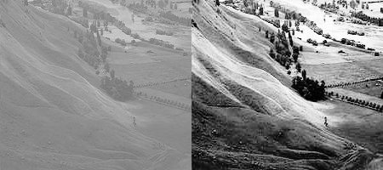

Fig9: Histogram Equalization

* Gaussian Blur:

Blurs an image using a Gaussian filter. This function convolves image. The function convolves the source image with the specified Gaussian kernel. In-place filtering is supported.

* Contour Detection:

Contours are simple curve joining all the points in an image. This method detects the edges of an image using the xy coordinate stored in numpy array.

* Erosion:

The basic idea is to erode away the boundary of the image. This is useful in the case where we have to remove small errors ie, white noises, detach two connected objects etc.

The pixel boundary is discarded depending upon the kernel size.



Fig10:Erosion

* Dilation:

This is opposite of erosion, it increases the width of the object. If atleast one pixel under the kernel is ‘1’, the size increases.



Fig11: Dilation

**3.4 Risk analysis and mitigation plan:**

Table 2:

|  |  |  |  |  |  |  |
| --- | --- | --- | --- | --- | --- | --- |
| Risk Id | Description | Risk Area | Probability | Impact | RE (P*I) | Mitigation Plan |
| 1 | Absence of a clinical expert who can study the fundus images and tell the accuracy of our project | Result Verification | H(0.9) | M(5) | M(4.5) | Explore university papers and accept their findings as our ideal output |
| 2 | Unavailabilty of noiseless images | Detection of DR | M(0.5) | M(8) | M(4.0) | Use of extensive amount of image processing algorithms |
| 3 | Unavailabilty of required libraries, like py or cv | Image Preprocesssing and DR Detection | M(0.4) | H(9) | M(4.5) | Makeshift algo |
| 4 | Hardware specs low | Training and Testing | L(0.3) | M(5) | L(1.5) | Reduce Dataset |
| 5 | Unavailabilty of DR resources and info | Detection of DR | M(0.5) | H(9) | M(4.5) | no |

Weighted Interrelationship Graph of Project:

Absence of a

clinical expert or

ground truth

6

Unavailabilty of

required libraries

/Open source modules

Unavailabilty of

noiseless images

7

9

7

5

Unavailabilty of

DR resources

and info

Hardware specs low

5

Risk Area Wise Total Weighting Factor:

Table3:

|  |  |  |  |  |  |
| --- | --- | --- | --- | --- | --- |
| S.no | Risk Area | # of Risk  Statements | Weights(In+  Out) | Total Weight | Priority |
| 1 | Absence of a  clinical expert or  ground truth | 2 | 6+9 | 15 | 3 |
| 2 | Unavailabilty of  noiseless images | 3 | 6+7+5 | 18 | 2 |
| 3 | Unavailabilty of  required libraries  /Open source modules | 2 | 7+7 | 14 | 4 |
| 4 | Hardware specs low | 2 | 5+5 | 10 | 5 |
| 5 | Unavailabilty of  DR resources  and info | 3 | 5+7+9 | 21 | 1 |

**Chapter-4**

**Implementation details and Issues**

Implementation steps:

1. The fundus image dataset is first preprocessed to make it easier on machine to run.
   1. Image sizes are converted into same dimensions or 640X491 to remove descripencies.
   2. Since the available dataset was having images in .png format to .jpg
2. Extraction of Optic Disk:
   1. Various methods are tested, as given by various papers. Finally, a different method is invented.
   2. Image in Green channel is extracted from its original, since yellow colour is high in green channel and optic disk is yellow in colour.
   3. Thresholding is done in the range of 200 to 250.
   4. contours are detected to encompass yellow regions and they are they labelled accoring to their size.
   5. Since optic disk is greatest in size, this contour is selected.
   6. A circle is drawn around the contour This circle is closest fitting circle.
   7. Another circle is drawn, with radius 1.5X of the previously drawn cicle. This is to insure that it encompasses the whole optic disk.
   8. A mask is drawn with this circle.
   9. This mask is then deleted from the orginal image.

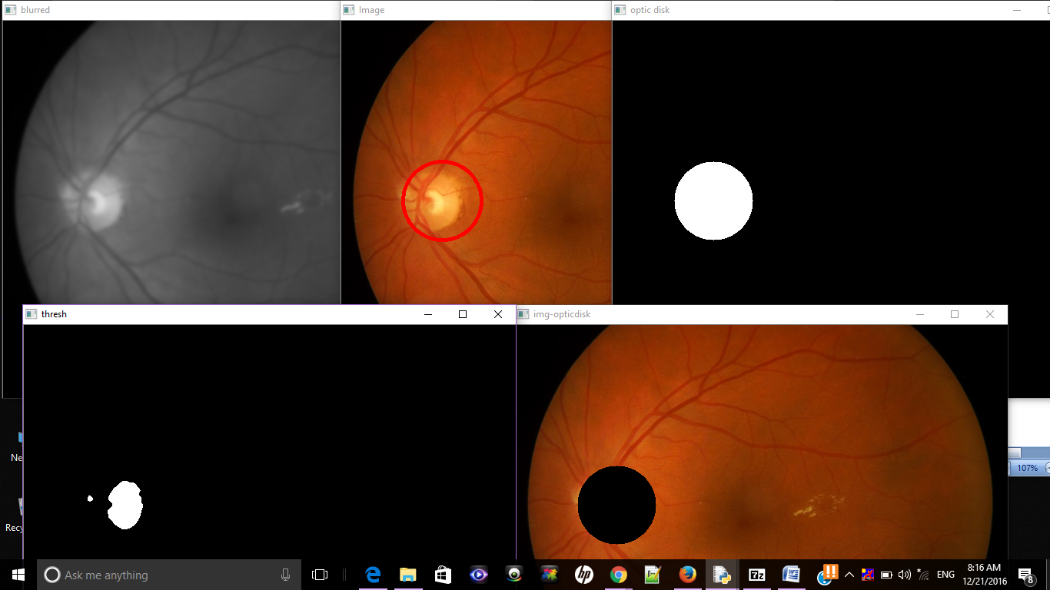

Fig12: Optic Disk Detection

1. Extraction of Blood vessel:
   1. Image in Green channel is extracted from its original, since red colour is high in green channel and blood vessels are in red colour.
   2. Two different kernels are made of varying sizes.
   3. Two different morphological closing are applied on the images using those two kernels.
   4. A gradient image is made by subtracting the kernel image and the original green channel image.
   5. Threshold is applied on the resultant image to get a binary image as an output. The rage of the threshold will varying according to the quality of images in the dataset. For now, it is hardcoded for the available dataset to 2,255.
   6. This image is then subtractedfrom the green channel image to give the desired result.

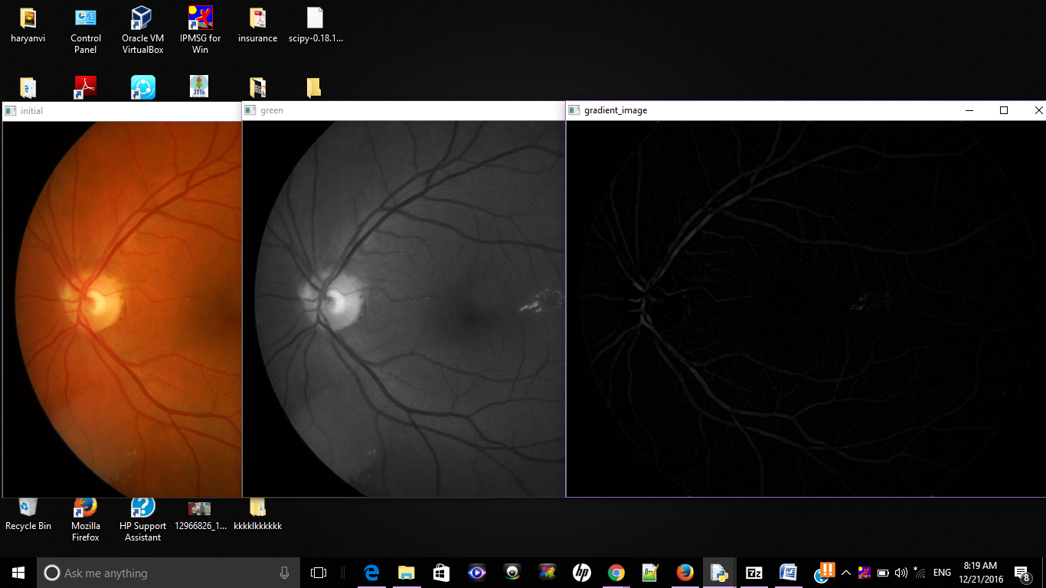

Fig13: Gradient image

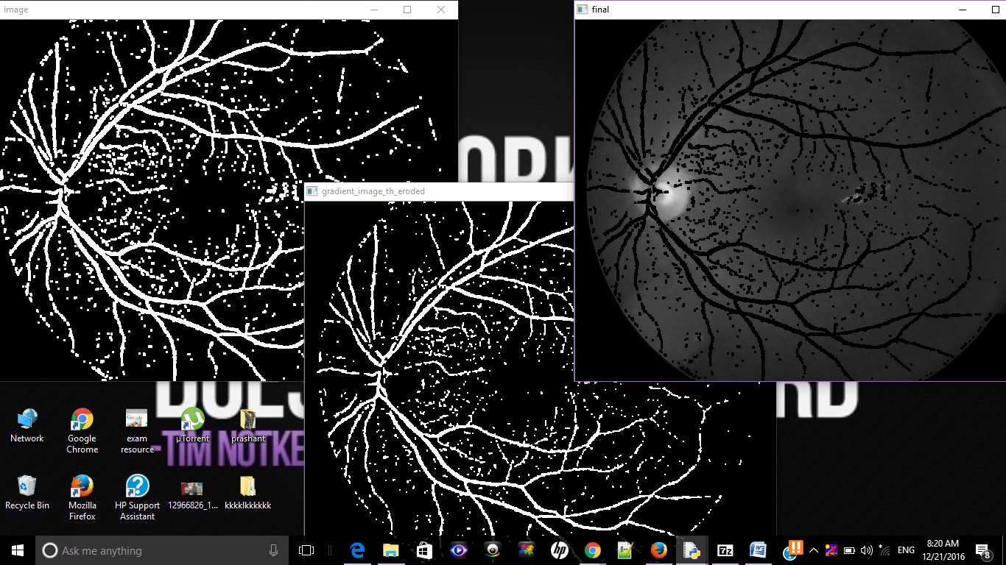

Fig14: Gradient Image after Thresholding

1. Detection of Exudates:
   1. Two kernels are generated and then applied to the green channel image, since exudates are yelllow in colour.
   2. Dilation of the morphological operation is used on two seperate images using one kernel each.
   3. Subtraction of the resultant two dilated images are done to highlight the edges of the yellow exudates in the fundus image.
   4. Threshholding is done for better contrast.
   5. Blood vessels and optic disk detected previously are removed from the resultant image to get the exudates.

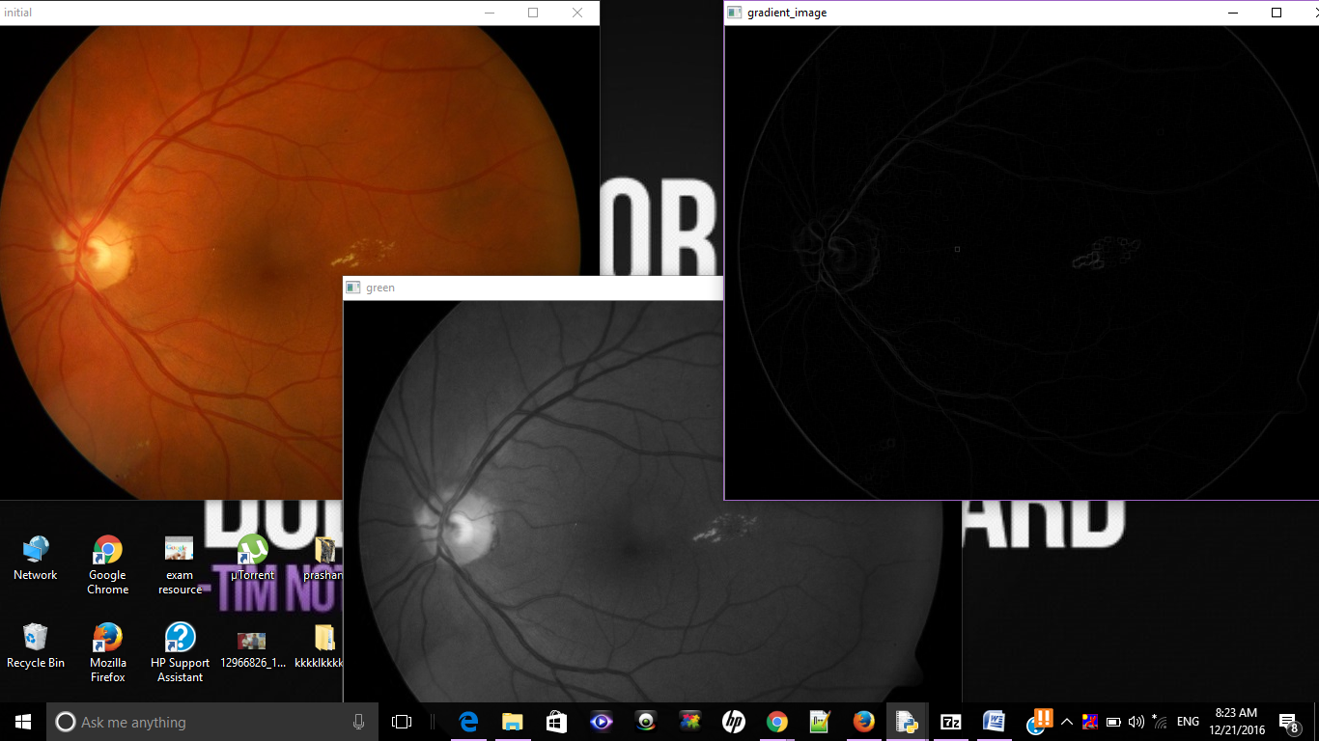

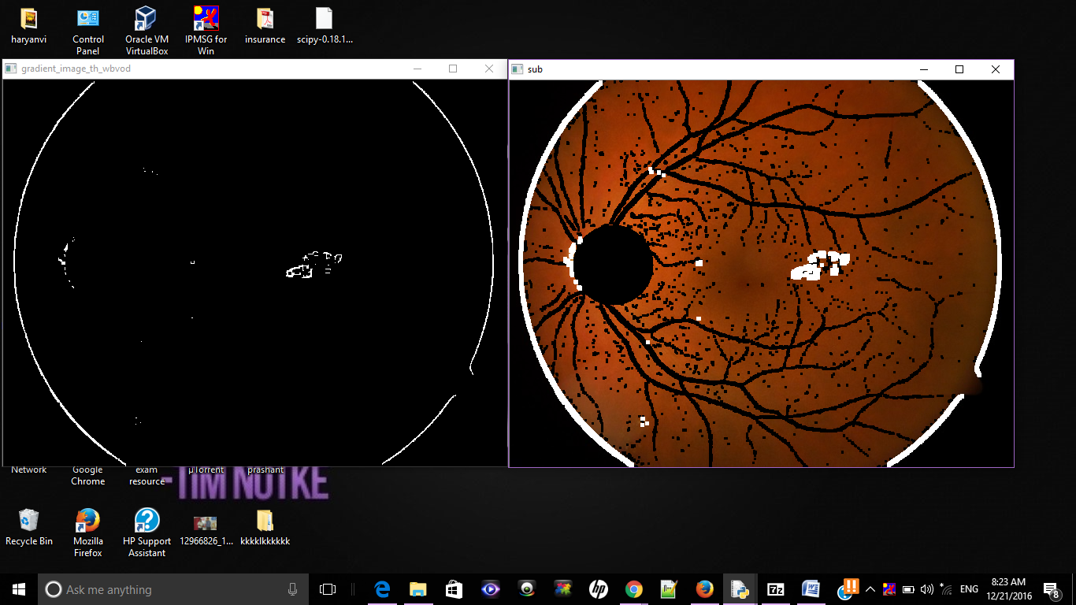

Fig15: Exudates detection

1. Detection of Dot Hemorrhages:
   1. A binary image is created by calculating red/green (R/G) intensities from the given fundus image.
   2. A 50 pixel median filter is applied to the resultant.
   3. Subtracting Red/Green ratio image and the resultant image.
   4. Applying threshold to the resultant image so that the red component of the fundus is visible clerly.
   5. The resultant image is converted into binary image and taken compliment of it.
   6. Canny edge detection is applied to the resultant image to highlight the dots in DHs.

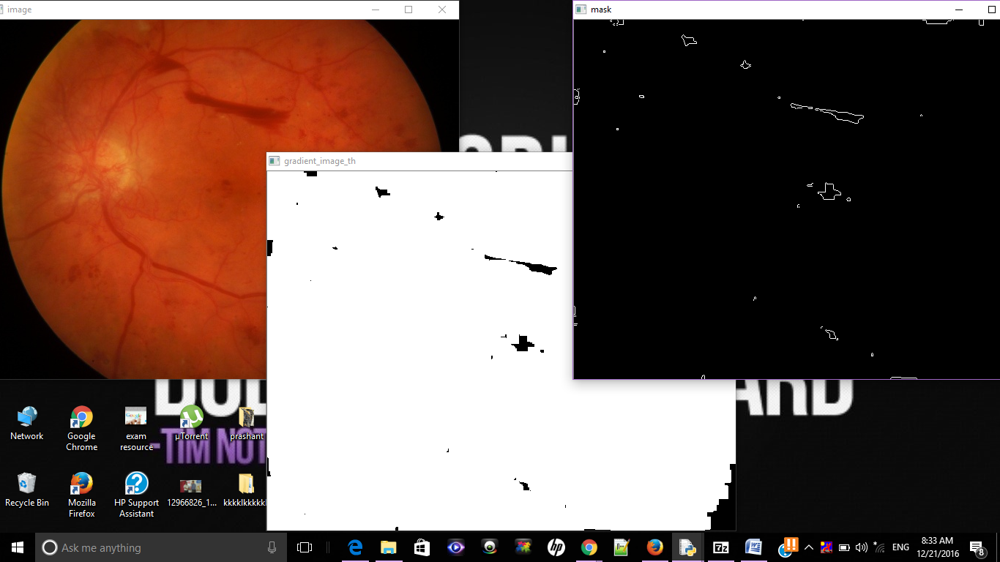

Fig16: DH detection



Fig17a: Classification

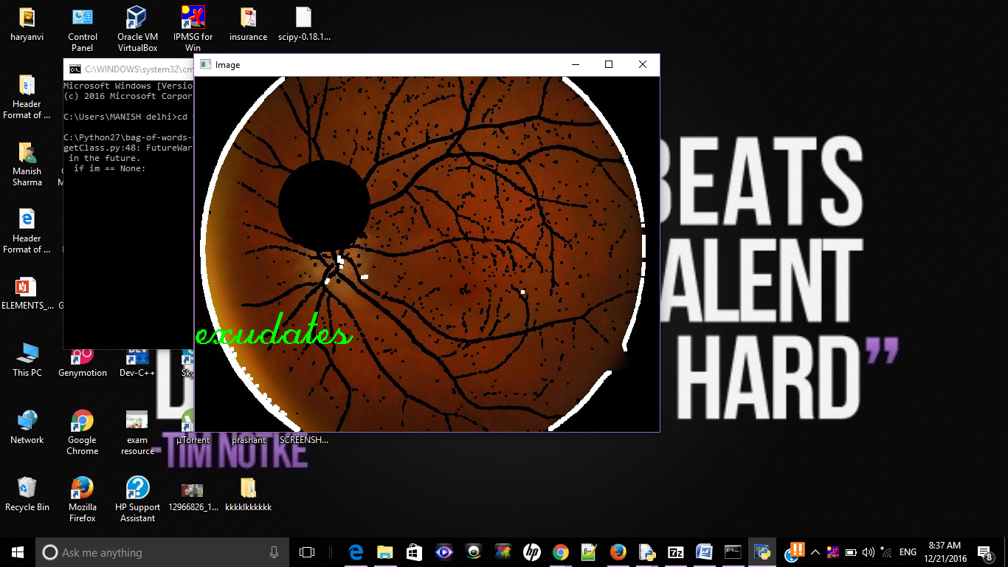

Fig17b: Classification

**Implementation details of machine learning part:**

* The required libraries and python distribution packages are included:
  + keras with TensorFlow backend
  + numpy for representing images in arrays
  + opencv to read write images
  + sklearn to do preprocessing on images
* The images to be trained are divided into 4 categories namely;
  + normal
  + dot hemorrhages
  + exudates
  + both
* grab the image paths and use preprocessing on them in order to distinguish their features among themselves
* reduce the resolution of the images to train them
* flattern the images into raw pixel intensities
* convert the labels from string to integers, into a vector where ith index is 1 and others are zero .
* The architecture of the network is as follows:
  + there are 4 layers :
    - 1st layer is the number of features in the image: 128x128x3. Since there are three chanells RBG
    - 2nd layer is the hidden layer and has 768 filters this number must be between number of input and output.
    - 3rd layer is again a hidden layer having 384 filters
    - 4th layer is the output layer which has 4 outputs corresponding to 4 classes of DR.
* The output is an array of probabilities for a specific image. The softmax function is applied to get the max of the probabilities.
* Stockhostic Gradient descent is applied to get the accuracy of each images. It is run for 50 epochs with 4 aas its batch size.

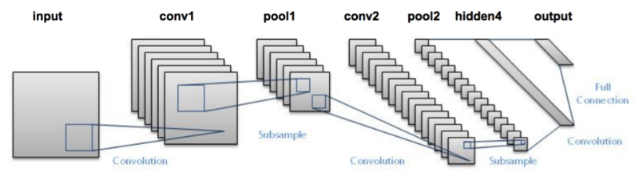 Fig18: ANN Model

**Chapter-5**

**Testing**

**5.1 Testing plan**

Table 4:

|  |  |  |  |
| --- | --- | --- | --- |
| Type of Test | Will test be performed? | Comments  /Explanations | Software Component |
| Requirements Testing | Yes | It is crucial to check the afeasibility of the project. It lets us know the needsa of the aproject, which will help in better developmenta of the aproject | This atest is the inital test that will be done on the project. Time, cost and abudget will evaluated from this. |
| Unit | Yes | This is an imporant one, since it points out where the bug is coming.This makes it economical to test the program as a whole | This test will be performed on individual blocks of code. |
| Integration | No | This test is required in very large projects where their integration is kept inot consideration. | Not required |
| Performance | Yes | This is required to understand the upper limits of our program. This tests the programs robustness in times of extreme load. | The software will  be tested to check if  it works properly if  there is load during  execution. |
| Security | No | This test is required to test confidentiality,  integrity,  authentication,  availability,  authorisation and  nonrepudiation. We dont need this in our project. | Not required. |
| Load | Yes | This will test how much can our program withstand when flooded with large dataset | This will be tested in the testing and training part of the fundus images |

The accuracy comparison with preprocessed and non-preprocessed images comes out to be this:

* for svm and processed: 60-65%
* for NN and non-preprocessed; 70-75%
* for NN and preprocessed: 73-78%

**5.2 Limitations of the solution:**

The Limitations of this solution lies in the fact that it has high chances of failing if the fundus images are not in proper intensity and/or they are not of high quality. This makes the algo hard to differentiate between dark regions and the the red DH, or sometimes, when the image is too bright, it cannot differentiate between exudates and optic disk. This may greatly hamper the result.

**Chapter-6**

**Findings & Conclusion**

**5.1 Findings:**

Through this project we were able to successfully detect exudates and Dot hemorrhages in fundus images. The dataset was initially trained without image processing and then, with image processing. The output in both the cases were noted down. The accuracy came out as follows:

Table 5:

|  |  |  |  |  |
| --- | --- | --- | --- | --- |
| Type | Exudates | Dot Hemorrhages | Both | Normal |
| Without Preprocessing | 42/82 | 34/80 | 14/72 | 18/22 |
| After Preprocessing | 74/82 | 66/80 | 50/72 | 18/22 |

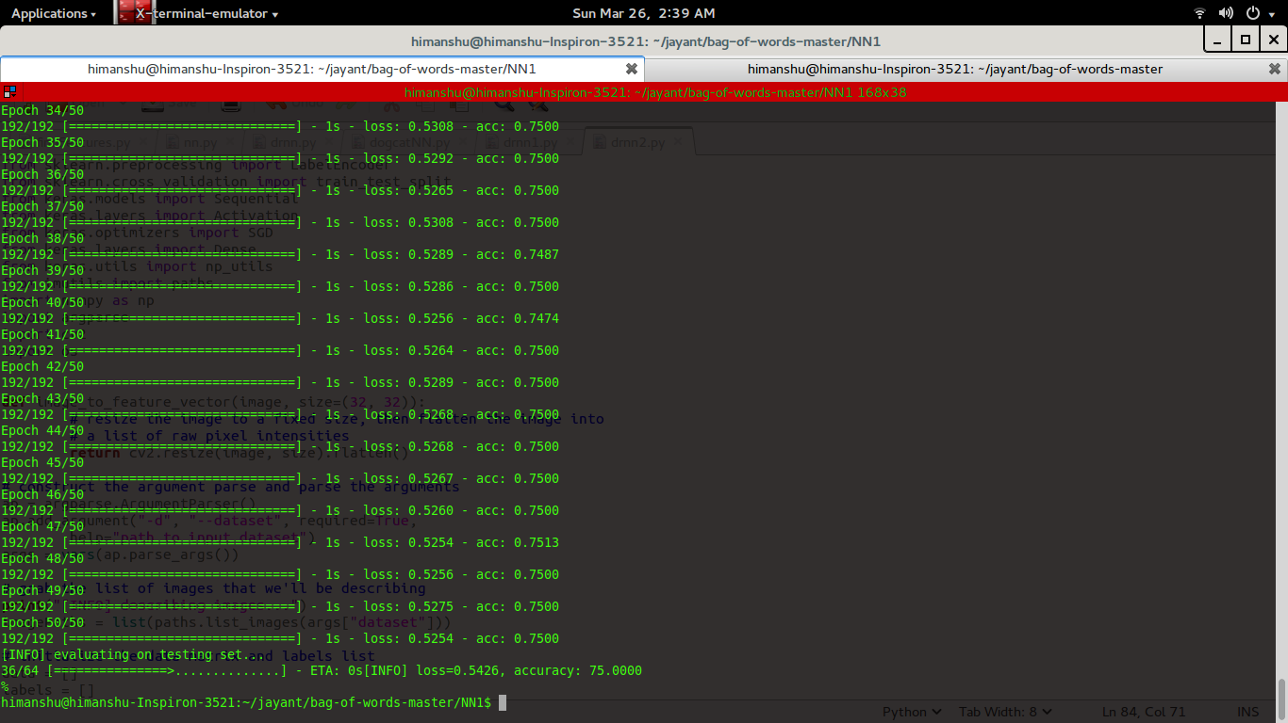 Fig 19: Classification using NN

**5.2 Concluion:**

After analysing the output it is clear that preprocessing is must for the detection of DR.

This project will help the opthalmologists to detect DR at early stage of a diabetic person and suggest medication early to prevent it from expanding. This will also help in detecting DR in bulk and getting the output in short period of time, thus saving the specialist from the pain of going through each and every image by himself and wasting time, which could have been devoted to the patients.

**5.3 Future Work:**

The scope for future work is huge in this field. We will further try applying different algorithms and will see which works best for which case. Also, a UI can be provided for manual input of the doctor, so that variables like Thresholding can be manually inputted as it gives more accurate result. This will also insure that the program works better even if used with low quality fundus image producing machines. With help of better hardware, the training of the fundus images can be improved tremendously.

**References:**

1. **Automated detection of bright lesions from contrast normalized fundus images,** Ashish Issac, Rishabh Madan, Malay Kishore Dutta, August 11 - 13, 2016, 2016Ninth International Conference on Contemporary Computing (IC3) , Noida, India
2. **Diabetic Retinopathy Screening Using Computer Vision**, Christopher E. Hann, James A. Revie, Darren Hewett, Dept of Mechanical Engineering, Geoffrey M. Shaw, August 12 - 14, 2009, Proceedings of the 7th IFAC Symposium on Modelling

and Control in Biomedical Systems, Aalborg, Denmark

1. **Dynamic Thresholding Technique for Detection of Hemorrhages in Retinal Images** Akhilesh Sharma, Malay Kishore Dutta, Anushikha Singh, M.Parthasarathi, Carlos M. Travieso, Las Palmas de Gran Canaria, August 7 - 9, 2014, 2014 Seventh International Conference on Contemporary Computing (IC3) , Noida, India
2. **Diagnosis of Diabetic Retinopathy,** Anupriyaa Mukherjeeet, February 2015, Int. Journal of Engineering Research and Applications
3. docs.opencv.org/3.0-beta/doc/py_tutorials
4. Dataset: http://www.it.lut.fi/project/imageret/diaretdb1/
5. **ImageNet Classification with Deep Convolutional Neural Networks,** Alex Krizhevsky, lya Sutskever, Geoffrey E. Hinton, University of Toronto
6. **Using Convolutional Neural Network for the Tiny ImageNet Challenge,** Jason Ting, Stanford University
7. wikipedia.org/wiki/Diabetic_retinopathy

**Appendices:**

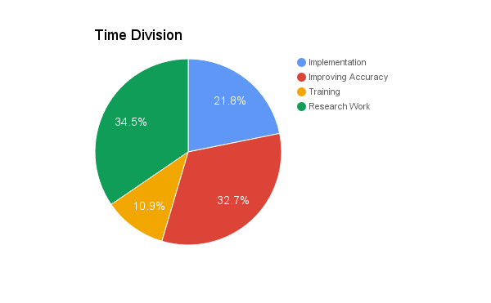

Fig20: Project Plan